nmtui  
IoT2050 网络设置  
1、DHCP  
2、手动设置  
3、设置DNS

[Autostart application in IOT2050](https://support.industry.siemens.com/tf/us/en/posts/autostart-application-in-iot2050/244062/?page=0&pageSize=10)

[Auto Start Application](https://support.industry.siemens.com/tf/us/en/posts/auto-start-application/251245/?page=0&pageSize=10)

[IOT2050 Clean Debian Image](https://support.industry.siemens.com/tf/ww/en/posts/iot2050-clean-debian-image/246710/?page=0&pageSize=10)

[update node-red](https://support.industry.siemens.com/tf/ww/en/posts/reinstall-the-image-iot2050/249927/?page=0&pageSize=10#post973958)

[Save SD image card image on PC](https://support.industry.siemens.com/tf/us/en/posts/save-sd-image-card-image-on-pc/240684/?page=0&pageSize=10)

[IOT2050 Clean Debian Image](https://support.industry.siemens.com/tf/us/en/posts/iot2050-clean-debian-image/246710/?page=0&pageSize=10)

[Looking for a method to enlarge the /dev/mmcblk1 disk to its maximum storage capabilities](https://support.industry.siemens.com/tf/us/en/posts/looking-for-a-method-to-enlarge-the-dev-mmcblk1-disk-to-its-maximum-storage-capabilities/244554/?page=0&pageSize=10)

[how can I use/get the watchdog functionalities/data described in the technical data](https://support.industry.siemens.com/tf/us/en/posts/watchdog-temperature/243596/?page=0&pageSize=10)

### [**修改启动顺序**](https://support.industry.siemens.com/tf/ww/en/posts/how-to-get-into-the-bios-to-enable-the-boot-from-usb-function/236125/?page=0&pageSize=10)

Boot the IOT2050 and login.  
Use command fw_setenv boot_targets  usb0 usb1 mmc0 mmc1.

mmc0 is the SD card, mmc1 is the eMMc.

Reboot the device and it will boot from USB, if there is a file the IOT2050 can boot.  
You can use fw_printenv boot_targets to check the current boot order

#### 临时修改启动顺序

1. use an UART cable u-boot shell
2. 选择启动盘
   * USB启动  
     run bootcmd_usb0
   * SD卡启动  
     run bootcmd_mmc0
   * eMMC 启动  
     run bootcmd_mmc1

there is one other way without erasing the eMMC and without an UART cable. Change boot order in Industrial OS to   
fw_setenv boot_targets usb0 mmc1 mmc0 usb1 usb2  
Plug in Service Stick and restart the IOT2050 -> boot from USBInstall Industrial OS and reboot Remove USB immediatelay after the IOT2050 starts the rebootIOT2050 boots into eMMc and the configuration setup opensPlug Service Stick back in and go through the setupOnce setup is finished the IOT2050 needs another reboot -> remove USB for this reboot

#### [**build Iot2050 image**](https://support.industry.siemens.com/tf/ww/en/posts/how-to-build-github-example-image/237116/?page=0&pageSize=10)

1. Create a new VM with Ubuntu 20.04
   * 2 cores
   * 4GB RAM
   * 50GB disk space
   * Internet access
2. Login to the VM as user (not root) and open a console

sudo apt update

sudo apt install docker.io

sudo usermod -aG docker $USER

1. Reboot VM

mkdir IOT2050_Images

cd IOT2050_Images

git clone <https://github.com/siemens/meta-iot2050.git>

cd meta-iot2050

./kas-docker --isar build kas-iot2050-example.yml

Iot2050 build log

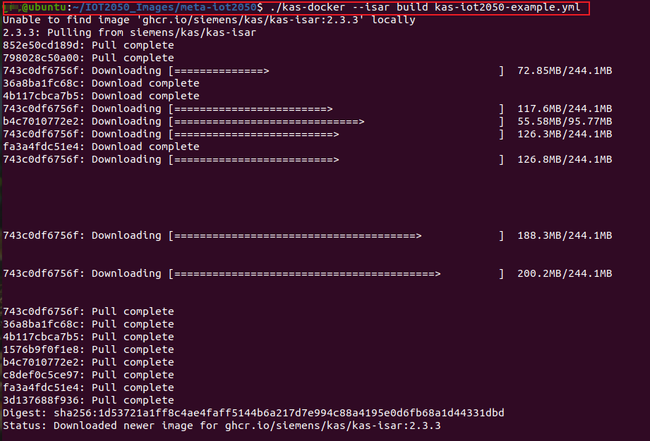  
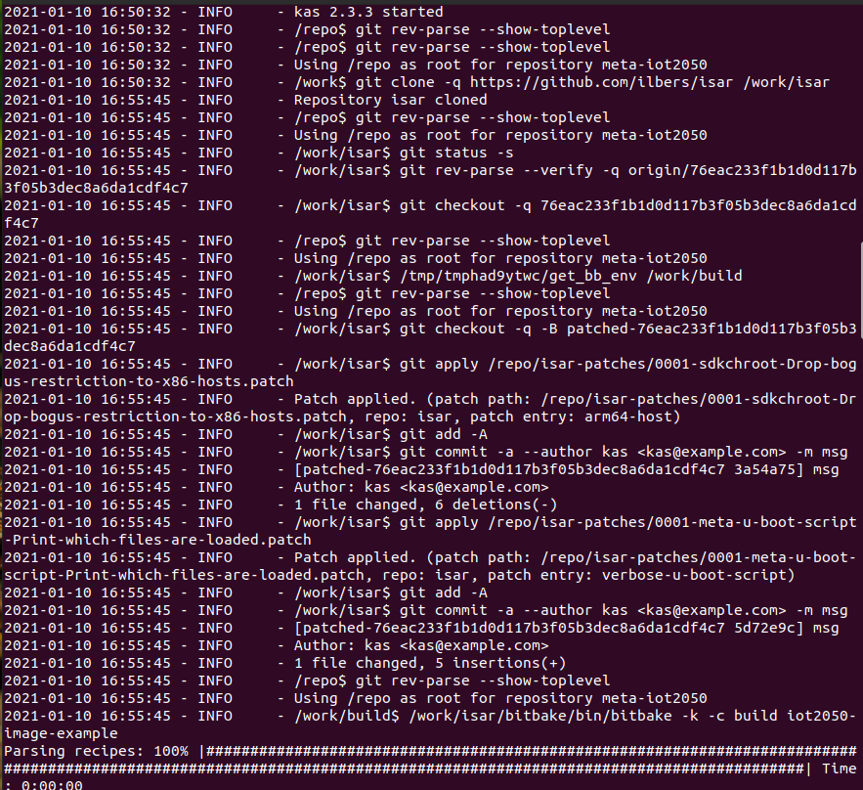

After creating the image can be found in

build/tmp/deploy/images/iot2050/iot2050-image-example-isar-iot2050.wic.img

For the first build at least 20GB of free disk space is required!   
Recommendation is to have at least 4GB of RAM and 2 cores.

#### [**安装镜像到eMMC**](https://support.industry.siemens.com/tf/ww/en/posts/how-to-install-example-image-to-emmc/238947/?page=0&pageSize=10)

sudo bmaptool copy build/tmp/deploy/images/iot2050/iot2050-image-example-isar-iot2050.wic.img /dev/mmcblk0

#### [**备份 eMMC**](https://support.industry.siemens.com/tf/us/en/posts/backup-emmc/248908/?page=0&pageSize=10)

Industrial OS Service Stick

Booting from this stick you can choose backup or restore the eMMc.

Another way would be to boot the Example Image from SD card and backup the eMMc with dd to an USB flash drive.

sudo dd if=/dev/sdb bs=100M conv=fsync status=progress | gzip > Iot2050.img.gz

#### [**删除 eMMc**](https://support.industry.siemens.com/tf/us/en/posts/boot-order/247127/?page=0&pageSize=10)

To erase the eMMc you need an Industrial OS or Example Image running on an SD card or USB drive.

1. Boot into the Industrial OS on the eMMc
2. Change boot order (example for having the Example Image on SD card)

fw_setenv boot_targets mmc0 mmc1 usb0 usb1

mmc0 = SD Card  
mmc1 = eMMC

1. Plug in SD card with Example Image. IOT2050 boots from SD card.
2. Erase eMMc with   
   mkfs.ext4 /dev/mmcblk1
3. Now remove SD card and plug in Industrial OS Service stick

The IOT2050 boots from the Service Stick and after installing the image it reboots into the eMMc and you can do the setup of Industrial OS.

#### 安装镜像到SD卡或USB

bmaptool copy Iot2050.img /dev/sdb --nobmap

sudo dd if=Iot2050.img of=/dev/sdb bs=100M conv=fsync status=progress  
系统启动后如果需用的目标存储器空间大于镜像空间，执行以下指令后reboot  
systemctl enable expand-on-first-boot.service

#### [**开机启动 Node-red**](https://support.industry.siemens.com/tf/us/en/posts/autostart-node-red/246854?page=1&pageSize=10)

node-red.service looks like this

[Unit]  
Description=Node-RED  
After=syslog.target network.target

[Service]  
Type=idle  
ExecStart=/usr/bin/node-red -u /home/root/.node-red  
StandardOutput=syslog

[Install]  
WantedBy=multi-user.target

This file is stored in: /usr/lib/systemd/system  
After saving the file execute: systemctl enable node-red

  
Remarks:

1. Check if you can find node-red.service
2. Don't know if this the case, but I installed the image on the emmc.

node-red logs  
cat /var/log/syslog | grep node-red

Systemctl status node-red

The file the application node-red will load is flows_iot2050-debian.json. Normally it's placed in the directory:/home/root/.node-red

you can check which tty device is used with this command:ls /dev/serial/by-id/ -l